Springboot Kafka with Producer and Consumer Configuration

Create a prject Producer with web, spring kafka and devtool dependency.

Project Structure is as mentioned below.

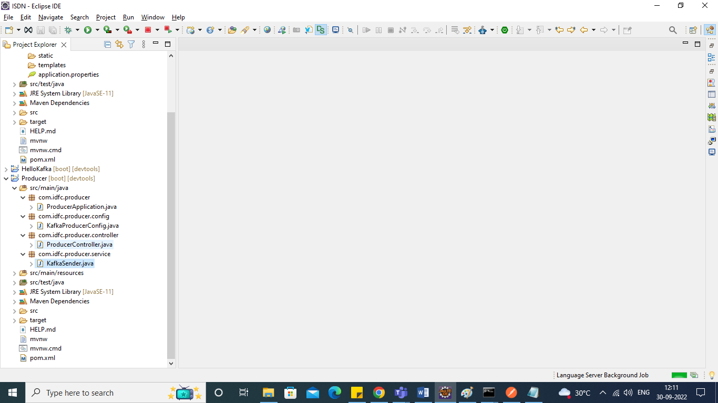

Create class Named KafkaProducerConfig.

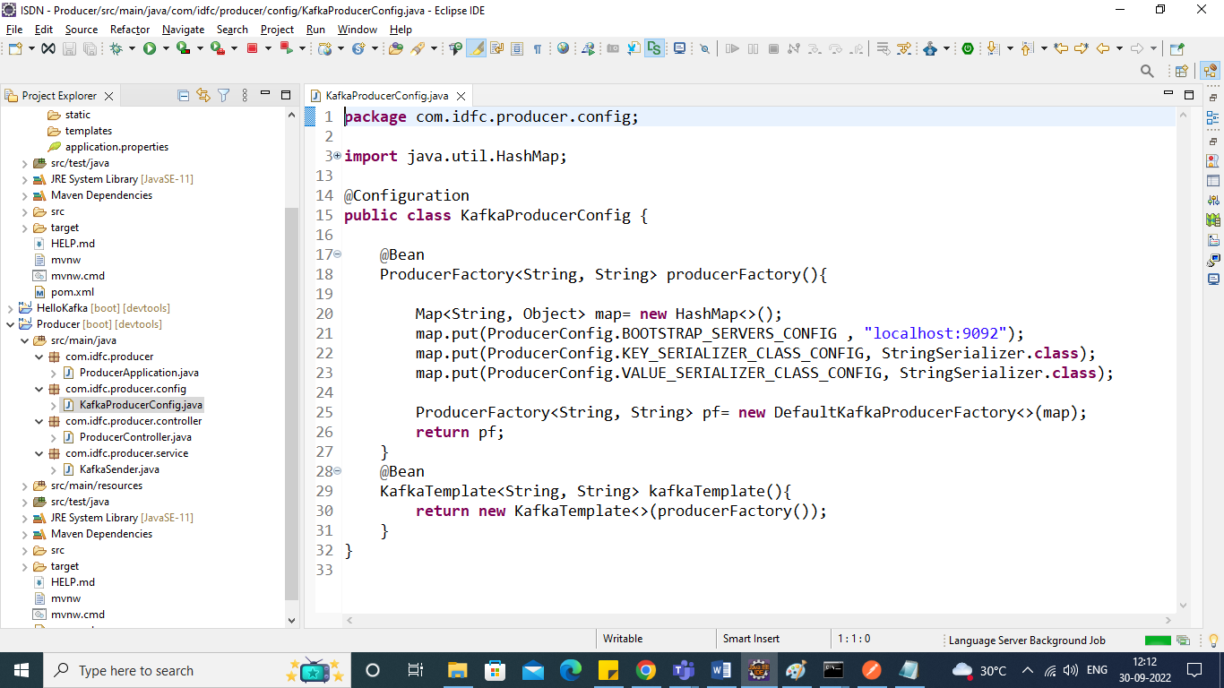

Create Service KafkaSender

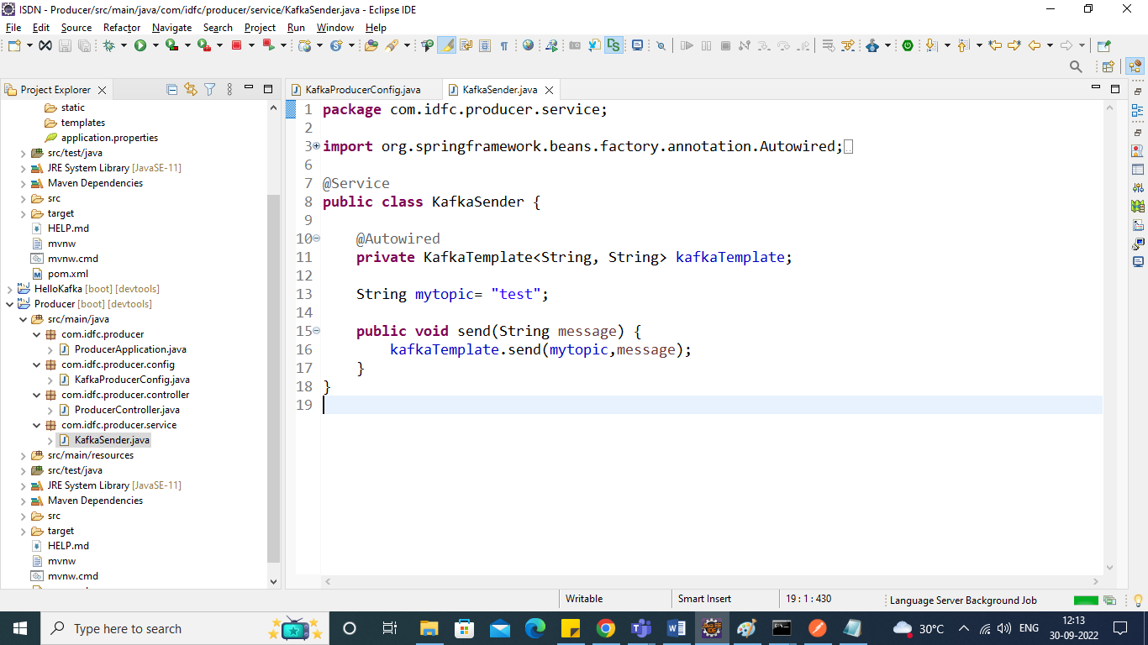

Create Controller ProducerController

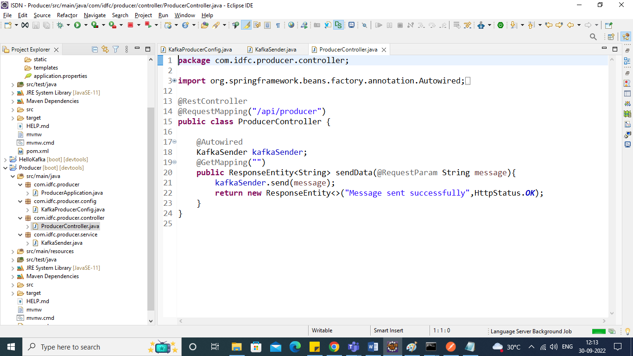

Run the Application

Check through Post Man and check Response in Consumer Console CMD

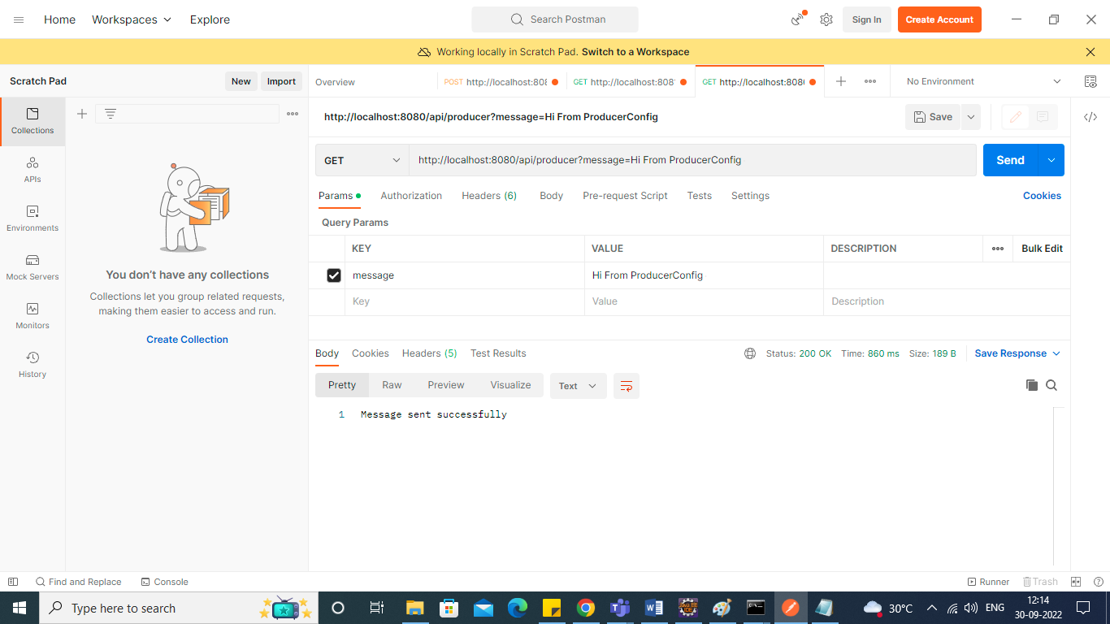

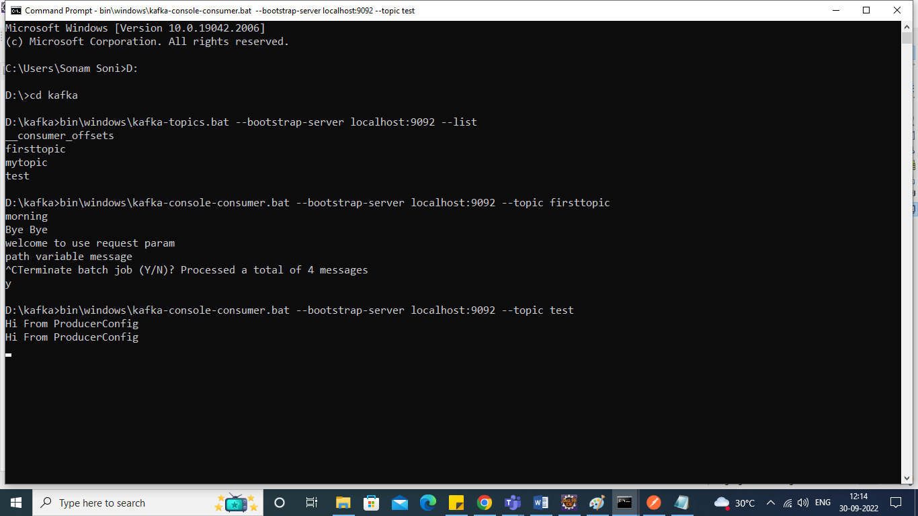

Let’s Create a Consumer Application to Listen Producers Messages.

Create Application Consumer with web,spring-kafka, dev tool dependency.

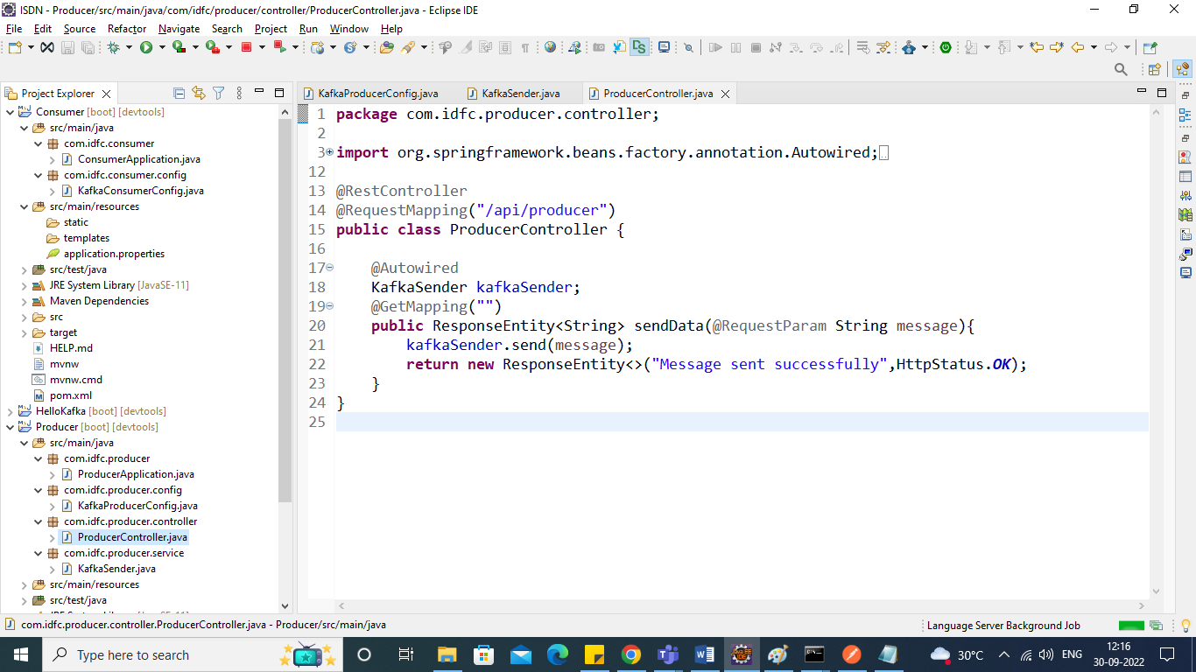

Project Structure

Create class KafkaConsumerConfig

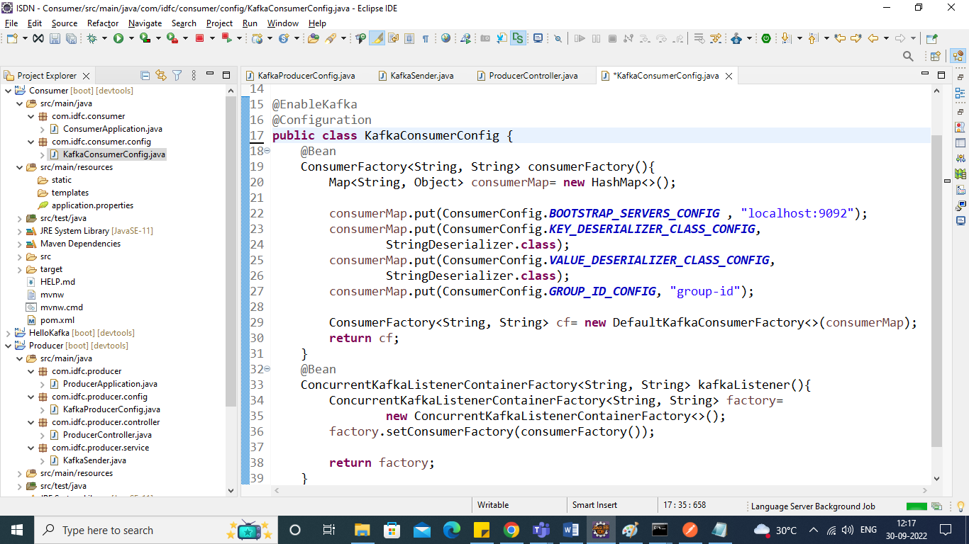

Enable Listener to the main Application

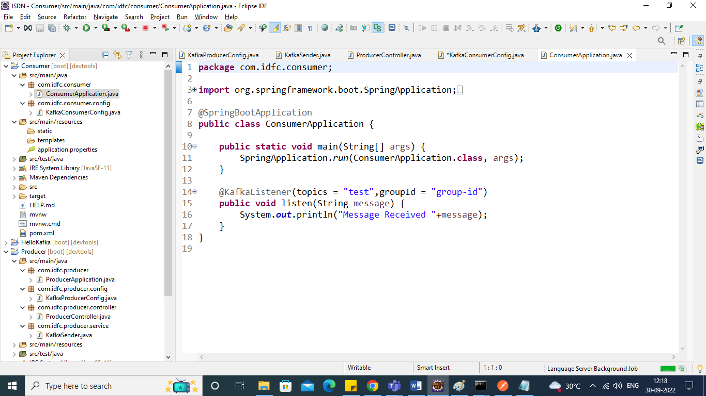

Run the Application, make sure you change the port number as you are running 2 applications.

After Staring this app If you send a message From Producer you can receive the same to Consumer Console Application.

